PNEUMATIC ASSEMBLY ON THE CHASSIS

**FSAE Rules Requirements:**

1. Gas chosen must be non-flammable.
2. The tank must be of proprietary manufacture, designed and buils for pressure to be used certified by an accrediting testing agency in the country of its origin and labeled appropriately

{Guerilla tank with a pressure rating of 5000psi is used}

.

1. The pressure regulator must be mounted directly onto the cylinder.
2. The gas cylinder/tank/lines must be protected from roll over, collision from any direction.( should lie inside the main roll hoop envelope)
3. The system should be insulated from any heat sources.
4. The axis of the cylinder must not point towards the driver.
5. Lines and fittings must be appropriate for the maximum operating pressure of the system (6 bar).

**Design Goals:**

The goal is to design, produce and test an electro-pneumatic gear shift mechanism. The aim is to aid the driver by achieving accurate (the driver need not remove his hands from the steering) and faster shifts for shorter lap times.

**Design considerations:**

1. General considerations:
2. The whole system should not be power consuming.
3. Must be weather and leak proof system (to work under al types of test during the events).
4. Each component must work under temperatures of 20-80 C(as the components are mounted close to the engine & gearbox).
5. 12kg force needs to be applied to the 42.5mm shift arm with approximate stroke of 12mm (calculated manually using a scale).
6. Should be capable of producing around 5000 gear shifts (theoretically).
7. Less air consumption, so as to get highest efficiency.

**Design**

Gearbox type: 6 speed sequential

What is shifting?

Shifting is referred to the process of gear change in an automobile. Over time race cars have developed various ways of shifting that saves time, confusion and damage to the engine. Studies have shown that the best drivers take 100 to 200 milliseconds to complete a gear shift.  However, as a race wears on the driver gets tired and these times can double or triple without the driver even realizing it. Thus an effective way of shifting is a top priority.

What is pneumatic shifting?

It refers to changing the gears with use of highly compressed air (or gas) which drives a piston, a lever attached to it gives the desired gear. The basic circuit for pneumatic shifting is given below.

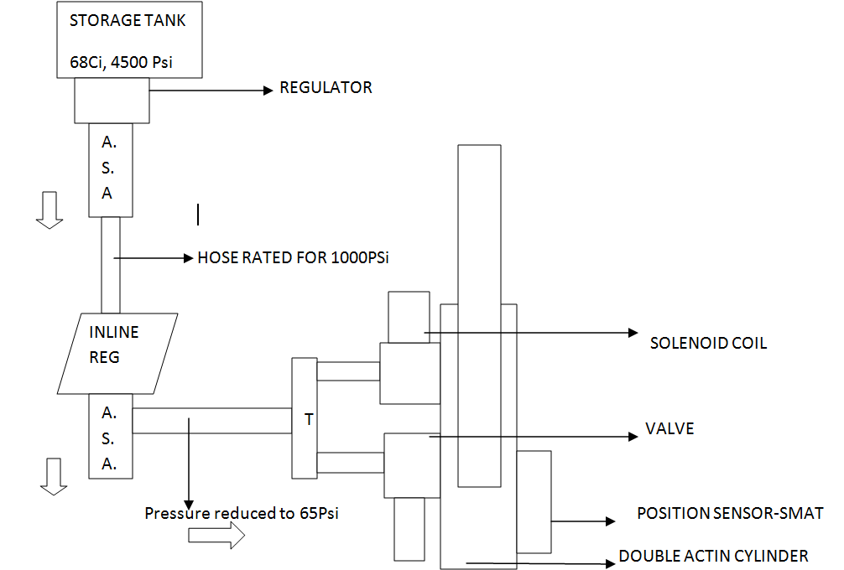

Why pneumatic shifting in a race car and why not?

Faster than normal manual shifts and better control on the steering without lifting off the hands but the setup considerably increases the weight on the car as compared to other methods like mechanical shifting or electrical shifting using electrical shifters. Helps in accelerating faster.

Basic parts required in the setup:

* High pressure compressed gas
* solenoid valves
* a double/single actuating cylinder
* Pressure regulators
* Pneumatic hoses and connectors, pipe threads to seal pipes on the screw threads
* Air source adapters.

Types of gases available for consideration:

* Compressed Air(78% Nitrogen).
* Carbon di Oxide:

Why only the above gases and not others in the discussions?

* Widely available
* Chemical stability and most imp of all-
* They can be pressurized and stored at reasonable temperature and pressure.

Which gas to choose?

* Highly Compressed Air:
* Affected less by large temperature changes
* Heavier tanks to withstand high pressure but can be filled easily.
* CO2:
* Its density varies exponentially with temperature
* It is a supercritical fluid(existing both as liquid and gas simultaneously)
* Non-reactive.
* Nontoxic nonflammable.
* Lighter mass of tanks as pressure is low when compared to nitrogen.

***Note:***

1. **Using CO2 is a major challenge because as the pressure drops so does temperature inside the tank. As CO2 goes out of the tank the pressure in the tank decreases which makes the tank cold (due to less pressure) and thus liquid co2 starts to boil to compensate for the gas that has escaped out. Boiling CO2 releases gas until there is enough pressure to keep the liquid from boiling.**
2. **Enough time is needed between each release of CO2 to avoid freezing due to sudden reduction in temperature.**
3. **Moreover if it leaks out through the regulator it could boil up to increase the pressure in the rest of the system and components may blow up if they encounter excess pressure than rated.**

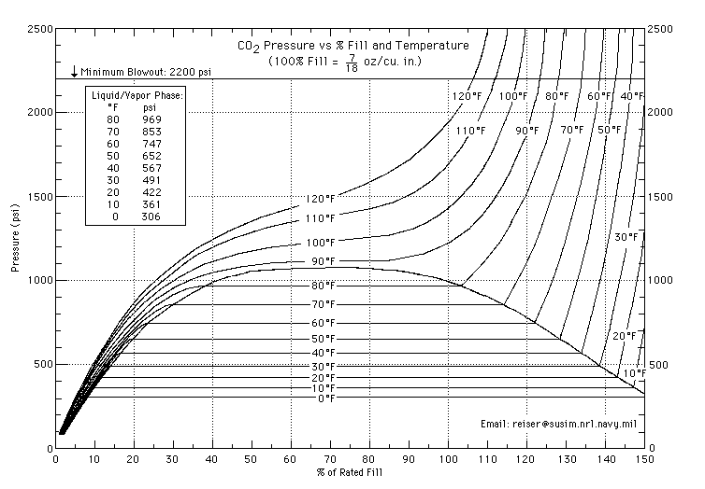

Above is the P-V Curve of Carbon dioxide fill rate in a tank with pressure. The pressure and temperature for a certain mass of CO2 filled in the tank were too high.

Some solutions to using carbon dioxide:

* M**ounting the tank upright**, allows gravity to keep the liquid always at the bottom. Thus liquid carbon di oxide will never enter the circuit.

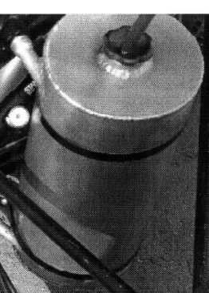

* A**nti-siphon tanks**:

Tanks with “J” shaped anti siphon tubes that always suck in gaseous CO2.

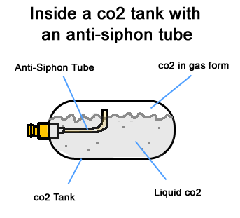

* **Remote hose**:

though not verified correctly, it is believed that the coiled hoses help keep CO2 warm this also gives the freedom to mount the tank vertical.

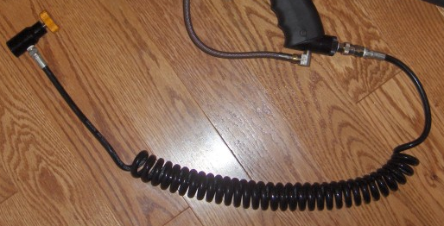

* **Expansion chamber**:

The most effective of all as it acts as a trap for liquid CO2 and allows only gas to move out through the vent hole. Temp and pressure both are reduced in this chamber thus keeping co2 in liquid form and controls the pressure of the gas at the exit from the chamber.

Calculations involved:

In this system, the process is assumed to be quick enough that there is no heat transfer into the system and only work that is done is assumed to be at the piston.

W= (pshift * A *Lstroke of piston)

The force is divided into 2 components. One to overcome the atm pressure and second that is needed to shift the vehicle.

Ptotal=Patm + Pshift= F/A + Patm

Also we have;

Change in internal energy= M*c*(T2-T1)= F*L

(Where T2 is the ambient temperature and later is that of the gas).

Consider ideal gas equation, and make the appropriate substitutions to get the mass of the gas used for one shift and the temperature of the gas.

PV=MRT

**Note:** Calculations of mass of gas per each shift reveals that CO2 is more effective gas when it comes to weight, but considering the complexity and risks involved in the system, it was not approved as a good option and thus nitrogen was chosen.

**FINALISED PARTS:**

* **Pneumatic tank: guerilla tank (paintball tank)**

Carbon fiber tank was chosen which was strong and simultaneously light weight.

Always keep the yellow cap on the tank thread to avoid there wear off.

It’s a high pressure device. Handle it with care.

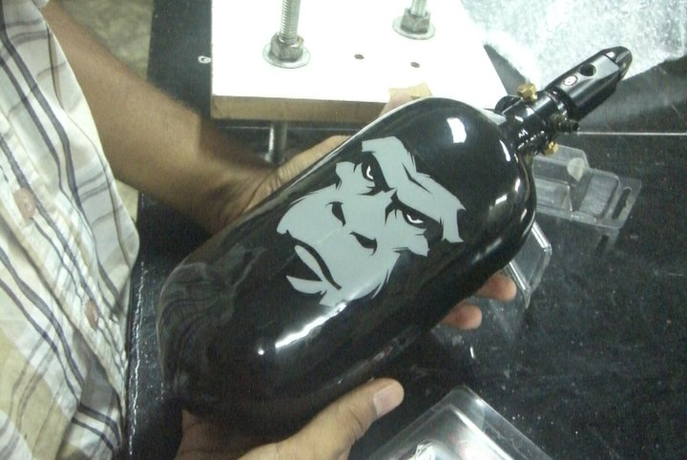

* **Actuation piston:**

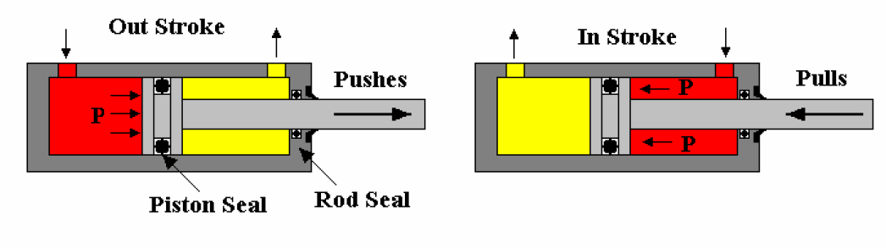

We will be using a double actuating cylinder as we need to move the shifter lever both clockwise and anti- clockwise. The red region in the above pic depicts the air flow and arrow indicates the motion of the piston.

We chose FESTO double actuating cylinder with piston diameter of 25mm and stroke of 25mm. for each shift the piston has to travel a linear distance of 10.5mm and thus it could be easily achieved with our choice of cylinder. pressure rating 10bar.

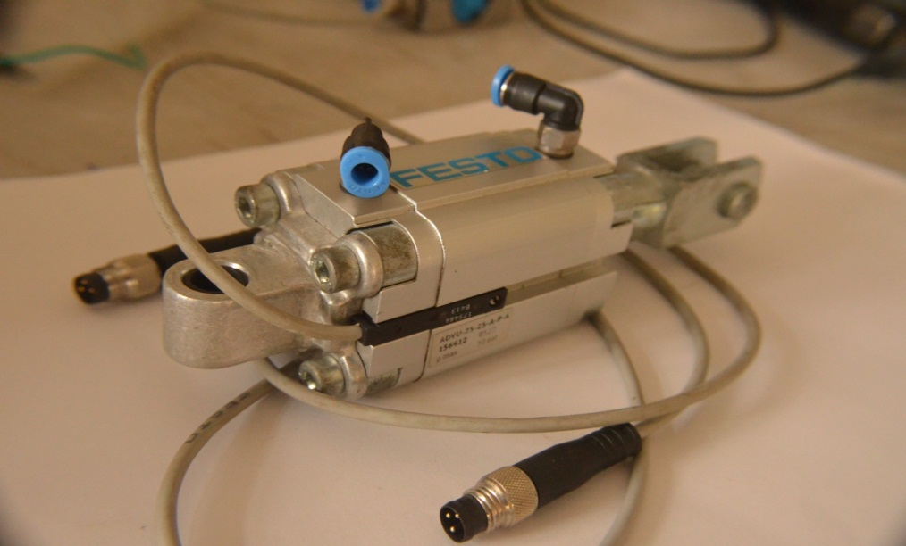

* **Proximity sensor**:

These sensors are positioned on the grooves of the piston. They sense the position of the piston.as and when the piston comes in the 10mm range of the sensor. It sends the signals to the solenoid valves, closing the gates and thus cutting off the supply of air.

* **Solenoid valves:**

They are like gates that allow the air to flow in and out of the system as and when needed. Electronic signals control amount of current in the solenoid coils and thus the magnet of actuation. We use 2 FESTO sponsored 3/2 solenoid valve which will be mounted using mild steel brackets.

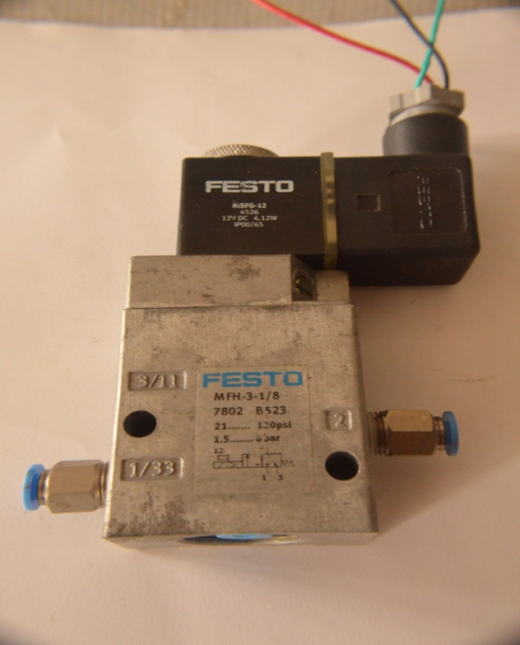

* **Pressure regulator (inline regulator**):

A paintball inline regulator was chosen which is a mechanical regulator with pressure rating of 800PSI. It is light, efficient and easy to operate. It was chosen over electric regulators to reduce power supply to the circuit.

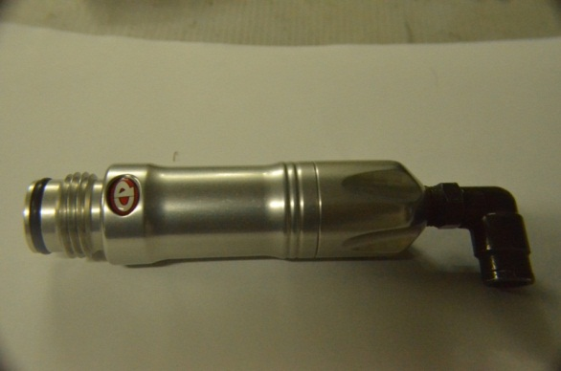

* **Pressure gauge:**

FESTO sponsored pressure gauge of 10bar pressure rating is used.

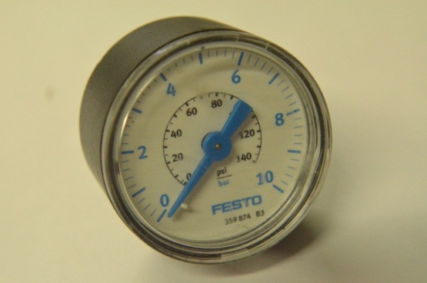

* **Air source adapter (ASA):**

These adapters are used to allow gas to flow or in order to degas the circuit before or after the event/test run. One is mounted on the tank while other is mounted on the inline regulator.

* It’s a device that shuts off the flow of gas when the tank is unscrewed thus preventing leak outs by locking into the pin valve of the compressor tank.
* It a very much required instrument in the setup.
* its chosen according to the pressure of the tank used.

2 ASA are chosen to degas the circuit with minimum loss in pressure and quantity of gas in the tank.

The ASA shown has a brass adapter specially manufactured. It was done because the threads on the ASA are NPT but that on the FESTO push in fittings are BSW.

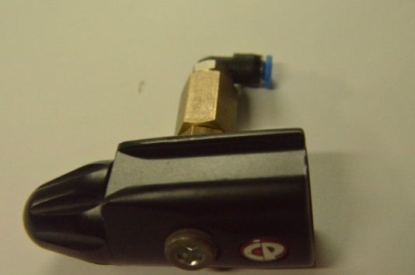

* **Flow control valve**:

They are mainly intended for pneumatic clutching wherein release of clutch has to be done in a controlled manner at a controlled rate to avoid sudden dumping. Will be mounted using zip tie

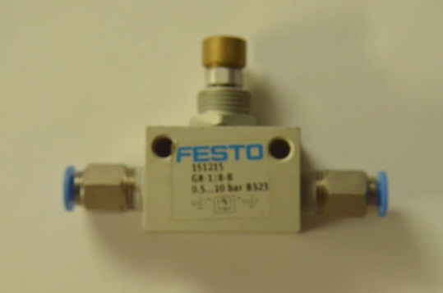

* **Pneumatic hoses:**

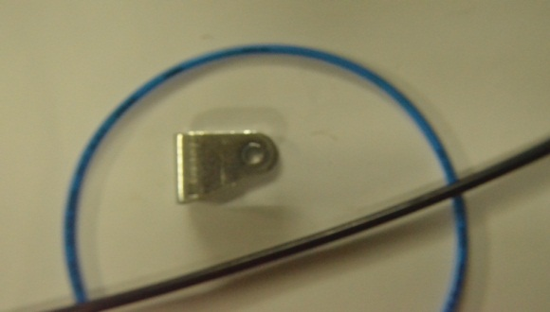

* Straight bonded polyurethane tubing sponsored by FESTO (blue pipes) for 1000psi rating.
* Polyurethane tubes were chosen as they are very popular with industrial pneumatic machines and can tolerate high pressure due to various properties of urethane.
* Steel pipes were a good option but would have considerably increased the weight of the system.
* Diameter: 4mm(blue hose)
* Diameter: 6.5mm(black)

Advantages:

* Excellent Impact, abrasion, cut resistance.
* Typically out performs rubber compounds up to 4x in abrasive applications.
* Superb resilience with exceptional elastomeric memory.
* Good temperature stability.
* Flexible enough

**NOTE: the 4 black pipes are imported from US and are not found in India therefore need to be handled with care. Please do not misplace them.**

**Design for manufacture:**

1. Pneumatic tank, solenoid valve, tubing and tube cutter.
2. Proximity sensors, push in fittings, flow control valve
3. Tank filling device, regulators, actuating cylinder(2)

(The above components were already sponsored from FESTO to previous team members)

Component mounting brackets:

Procedure: laser cut.

Material: mild steel

Fixing: by welding onto the chassis

* Pressure gauge, regulator, valves and pivot point of the piston will all be mounted by these type of brackets as shown below.

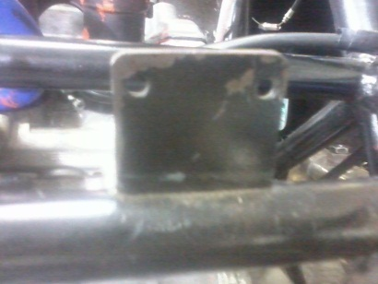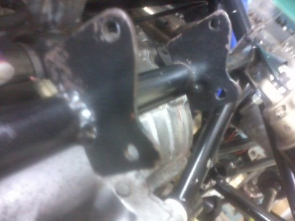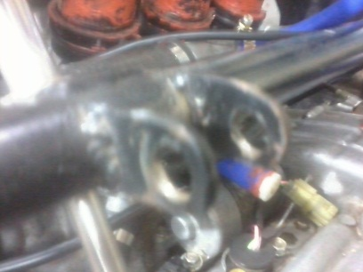

Regulator mount solenoid mounts piston pivot mount

1. Solenoid etc. protection:

Procedure:

1. Buy/ manufacturing by gluing 4 plastic sheets together in a form of a cuboid

We might also use plastic bags (zip pouch) for other accessories.

1. Tank mounting unit:

Procedure: metallic mount to be clamped onto the main hoop braces

Material: aluminum.

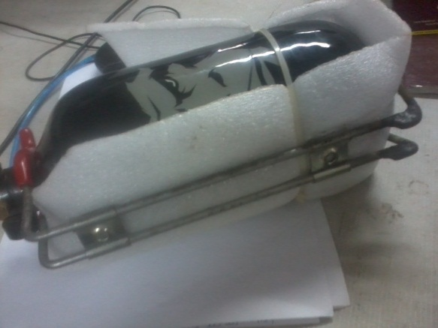

𨢁

**Testing:**

**Problems faced:**

1. Leakage:

In the preliminary set up, leaks were observed and were repaired by cutting the wires again using the FESTO tubing cutter provided by FESTO.

Leaks were also there in the pressure regulator and were rectified.

1. Calibration of reed sensors:

The reed sensors sense the piston over a range of 10mm & send the signals to the ECU. Range overlap will lead to improper timing of the solenoid valves

1. Double shift:

Probable cause-improper positioning of the reed sensors and thus behaving differently because of the return spring.(range overlap)

1. Achieving neutral:

Because of range overlapping neutral was being achieved this should not theoretically happen as shift from 1st to 2nd and vice-versa are complete shifts while neutral is a half shit i.e. it needs lesser force to operate.

**Design for Assembly:**

(See circuit diagram for reference).

* Pressure tank(Guerilla tank):

a holder like one used for fire extinguisher is attached to the tank.

It will then be clamped to the chassis member via circular clamps.

Mount one of the ASA on the tank.

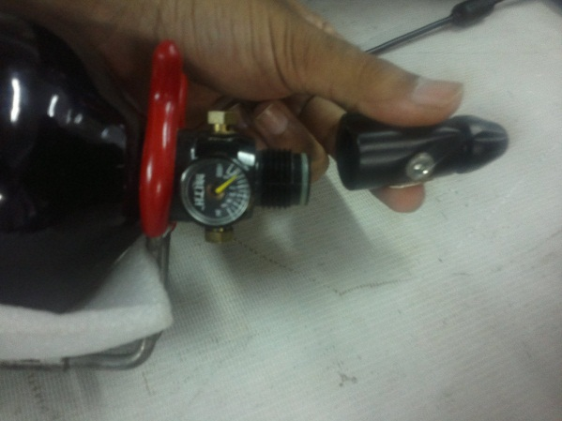

* A black hose will be connected from the ASA on the tank to the push in fitting on the inline regulator.

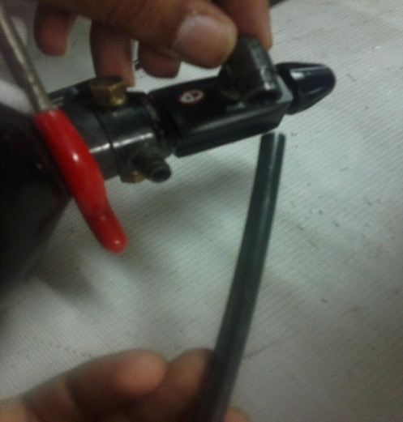

* An ASA will be screwed to the regulators opposite end and blue hose will be connected to the push in fitting at his end.

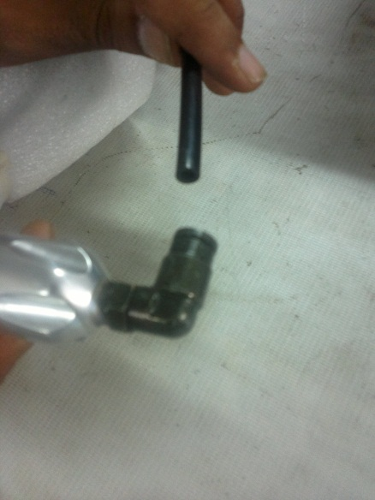

* A T joint will be connected at the free end of the above blue hose.

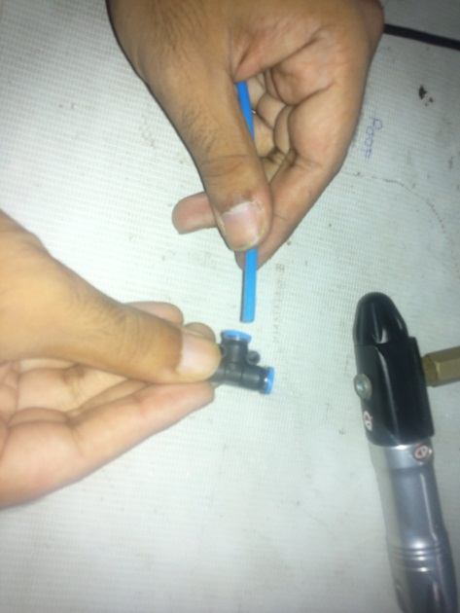

* One hose from above joint will go into the pressure gauge and the other one to another T joint. This pressure gauge will be mounted will the help of a zip tie onto the chassis member.

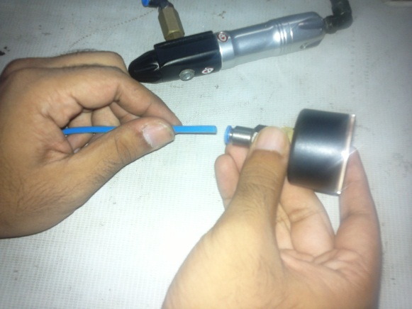

* Blue lines (hoses) from both free ends of the second T joint will be inserted into the intake ports of the each solenoid valve.

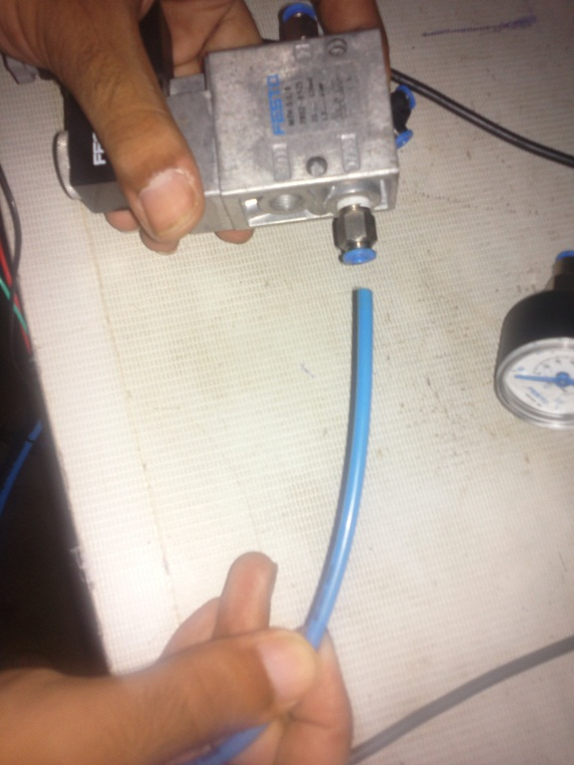

* Blue hose will be connected from the solenoid to the corresponding piston inputs.

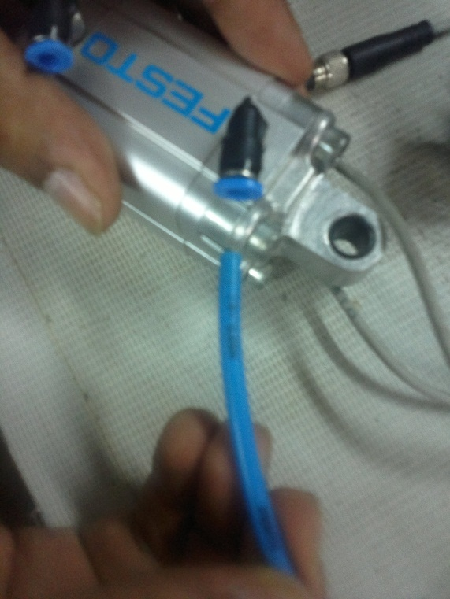

* Solenoid valves are mounted on to the brackets with the help of bolts M5 that will be inserted into the bracket holes.
* And zip lock is considered to cover the solenoid to provide water proof system.
* The actuation piston is mounted with the help of bracket and a M8 bolt is used to clamp the piston to the bracket.

INTRODUCTION:

For the clutch to get engaged, a torque of 6300Nmm should be applied on the clutch lifter pin(inside the clutch housing). The above torque goes correct with a default clutch fork lever of 35mm.

For correct and complete actuation of the clutch, the arm on the clutch fork must travel a linear distance of 15mm.

Design Requirements:

* The system should be reliable under all conditions( eg. Vibrations , temprature)
* Adjustable free play should also be incorporated
* Easy to dismount in case required, without disturbing other components
* Proper dumping of clutch to avoid excessive wear.

Working: